Food Delivery Management System
Project Report
Project Description
A backend-based REST API application built with Node.js, Express.js, and MongoDB to digitally manage movie theater operations including Orders, Customers, Staff, and Restaurants . The system exposes full CRUD APIs tested via Swagger UI and Postman — no frontend required.
Tools & Technologies
Tool / Package | Version & Purpose
Node.js | v20.x LTS — JavaScript runtime environment
Express.js | v4.x — Web framework for building REST APIs
MongoDB | v7.x — NoSQL database for data storage
Mongoose | v8.x — ODM library for MongoDB schema & relationships
Swagger UI (swagger-jsdoc + swagger-ui-express) | v6.x / v5.x — Auto-generated API documentation in browser
dotenv | v16.x — Environment variable management (.env file)
VS Code | Latest — Code editor

Entities (Collections in MongoDB)
Entity | Key Fields
Staff | name, role, phone, department, status, orders_assigned, created_at
Customers | name, email, phone, address
Restaurants | name, address, cuisines, open_hours, rating
Orders | customer_id, restaurant_id, items, status, total_price

Relationships / Mappings
- One-to-Many → One Restaurant has many Menu Items and many Orders.
- One-to-Many → One Customer can place many Orders.
- One-to-Many → One Staff member can be assigned to many Orders.
- Many-to-One → Many Orders belong to one Restaurant.
- Many-to-One → Many Orders belong to one Customer.
- Many-to-Many → Staff can belong to one Department, and Departments can have multiple Staff.
CRUD Operations (All 4 Entities)
Operation | API Method & Endpoint Example
Create (Insert) | POST
Read (Select) | GET
Update | PUT
Delete (Drop) | DELETE

Summary
The Food Delivery Management System project successfully demonstrates the development of a robust backend REST API using modern technologies. Below is a summary of the key aspects:
Project Highlights:
Aspect | Summary
Project Type | Backend REST API
Total Entities | 7 (Staff, Customers, Restaurants, Menu Items, Orders, Departments, Analytics)
Total Endpoints | 31 (CRUD operations for all entities + Analytics)
Database | MongoDB (Native Driver)
API Documentation | Swagger UI (auto-generated)
HTTP Status Codes | 200, 201, 204, 400, 404, 500
Testing Approach | Manual testing using Swagger UI and Postman
Code Structure | Modular (separate config, routes, and controllers)
Environment Variables | Managed via .env file
Deployment Readiness | Fully functional and ready for cloud deployment
Key Features:
- Complete CRUD Operations – All entities support Create, Read, Update, and Delete.
- Swagger Documentation – Interactive API documentation for easy testing.
- Analytics Dashboard – Real-time statistics including total orders, customers, restaurants, and revenue.
- Error Handling – Proper error responses with meaningful messages.
- Modular Architecture – Clean separation of concerns for maintainability.
- Environment Configuration – Secure management of sensitive data via .env.
Conclusion:
The Food Delivery Management System API successfully fulfills its objective of providing a scalable, well-documented, and fully functional backend system for managing food delivery operations.
Strengths:
- Scalable – Modular structure allows easy extension with new features.
- Well-documented – Swagger UI provides auto-generated, interactive documentation.
- Tested – All endpoints were validated with Swagger UI and Postman.
- Production-ready – Can be deployed to cloud platforms like AWS, Heroku, or Render.
- Secure – Environment variables protect sensitive data.
- User-friendly – Clear error messages and consistent HTTP status codes.

Future Scope:
Feature | Description
Authentication & Authorization | Implement JWT-based login and role-based access control.
Frontend Integration | Build a React/Angular dashboard for a complete user experience.
Real-time Order Tracking | Use WebSockets for live order status updates.
Advanced Analytics | Add graphical reports and data visualization.
Cloud Deployment | Deploy on AWS, Heroku, or Render for public access.
Payment Integration | Integrate payment gateways like Razorpay or Stripe.
Mobile App | Develop a mobile app for customers and delivery partners.

Screenshots of the API:POST

Here I have used the post command on the staff which means I have added a new member in my database with name Aman Kumar along with the details of role and phone and dept . (I have shown only one entry of them) As depicted by the image the entry has been added to database of staff. Similarly I have created for my other entities as well the images of them are attached below : (Firstly I have added the confirmation which shows that the entry has been successfully added and a unique id has been generated for the entry )

For customers

For Restaurants

For MENU

For Dept

GET
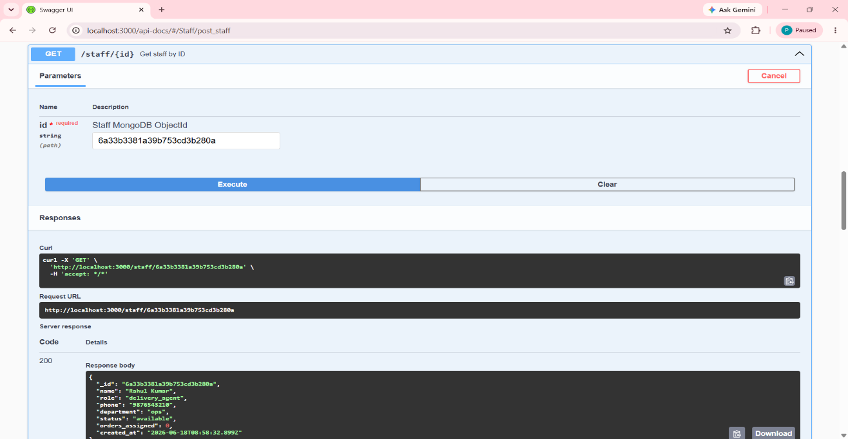

In this it searches for the entry via a unique feature here the unique fig is the id and I have identified via the id I created in the post (the same id has been created) .Similarly I have done in the other databases
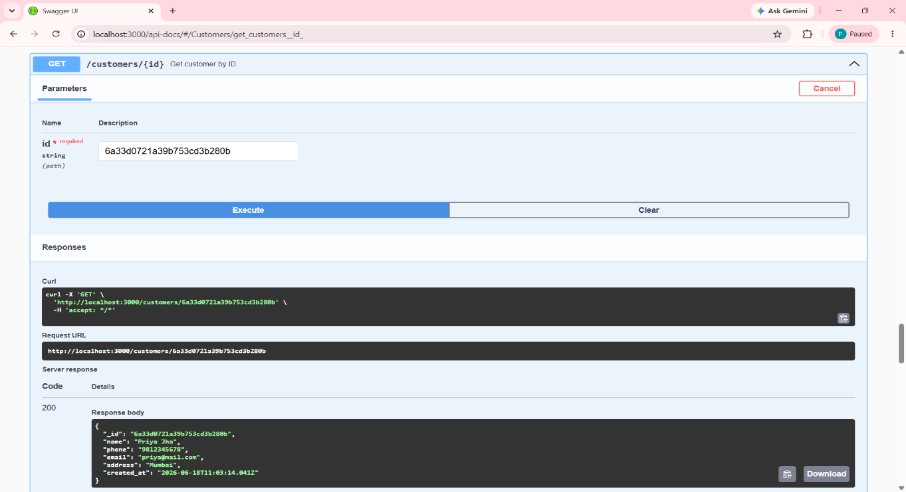
For customers

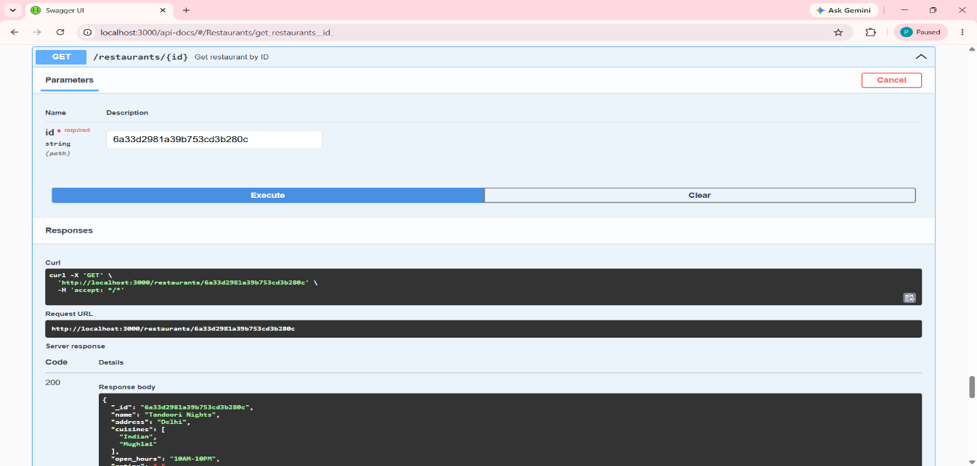
For Restaurants
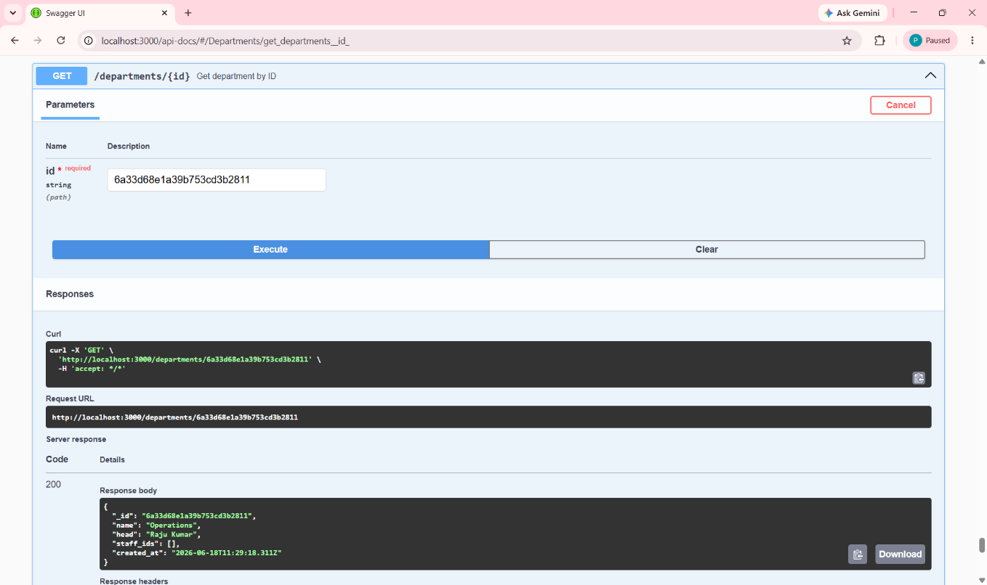
For Dept
PUT
Put is used to update the details. It means to change the value set from one to another

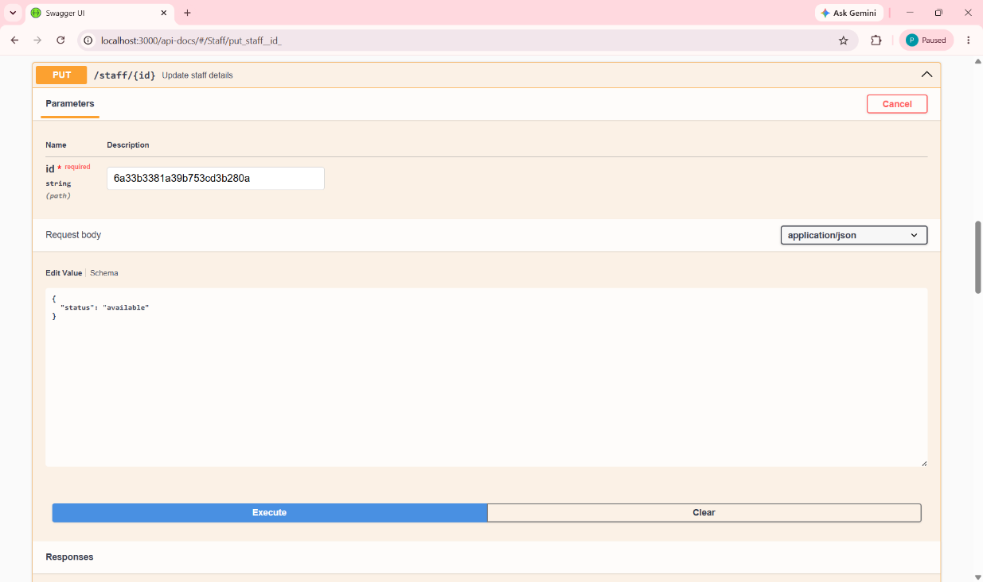
Here I have updated the status from being unavailable to being available whose id (of Aman Kumar) via put in swagger Similarly I have done in the other databases. The screen shots are given below:
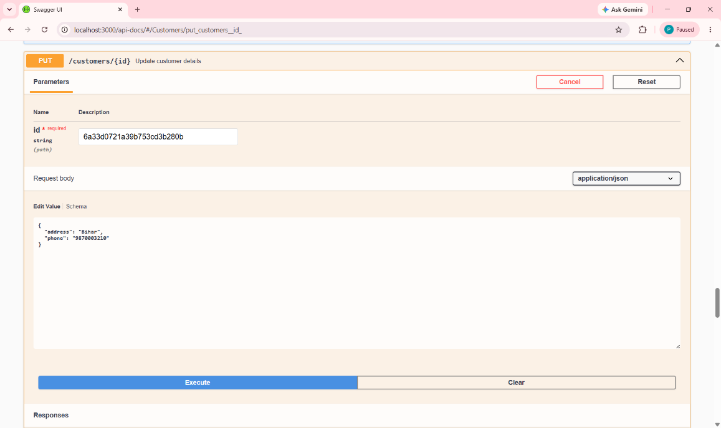
For customers
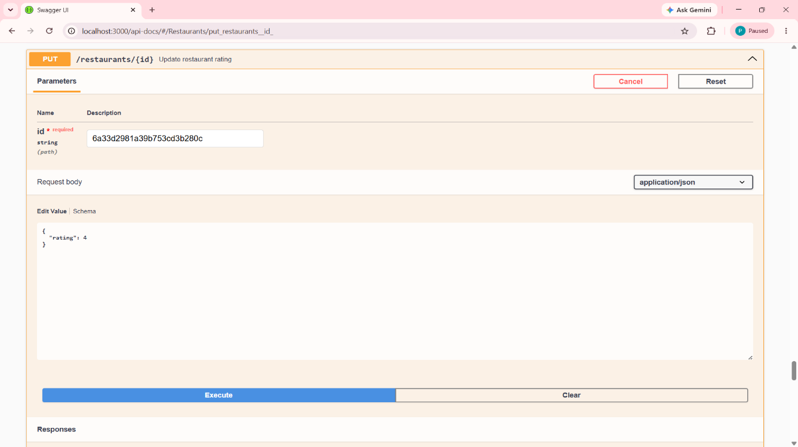

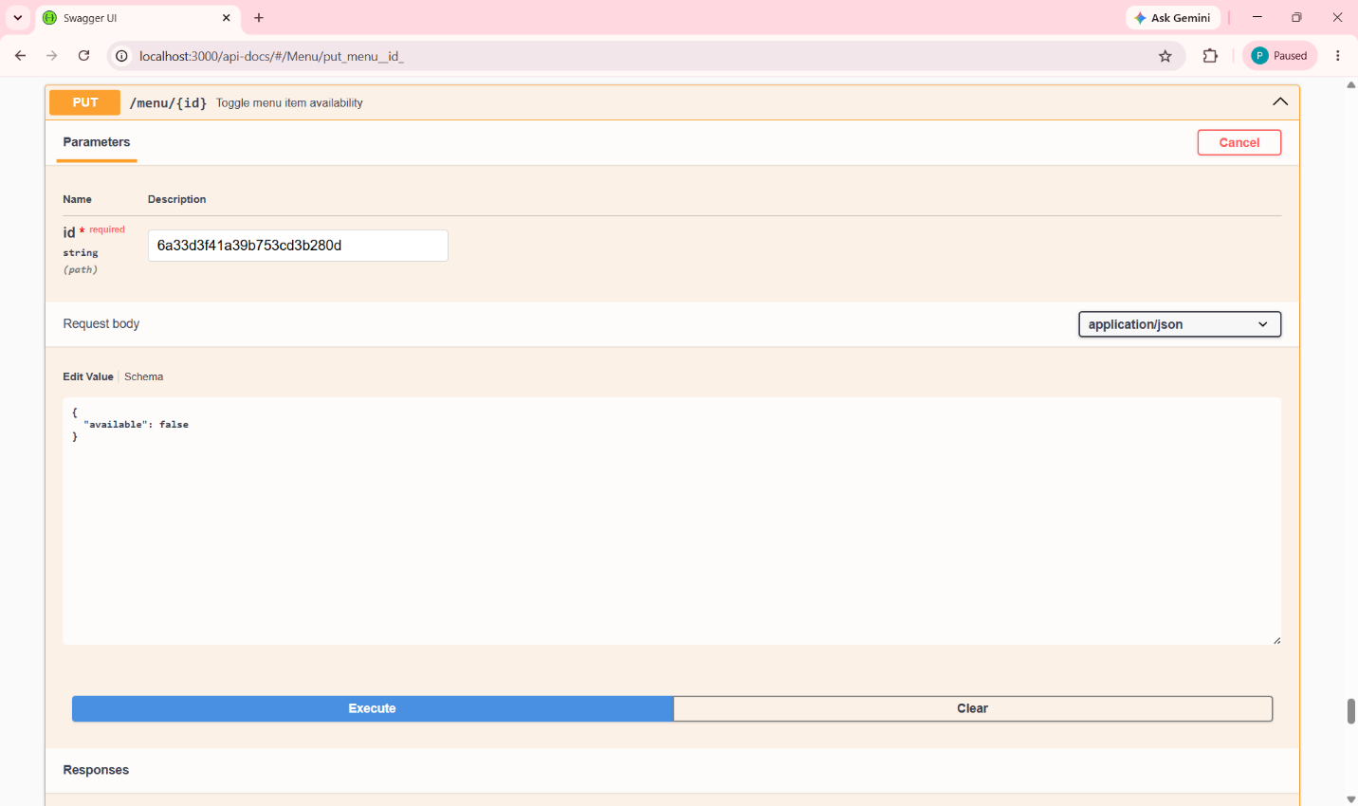

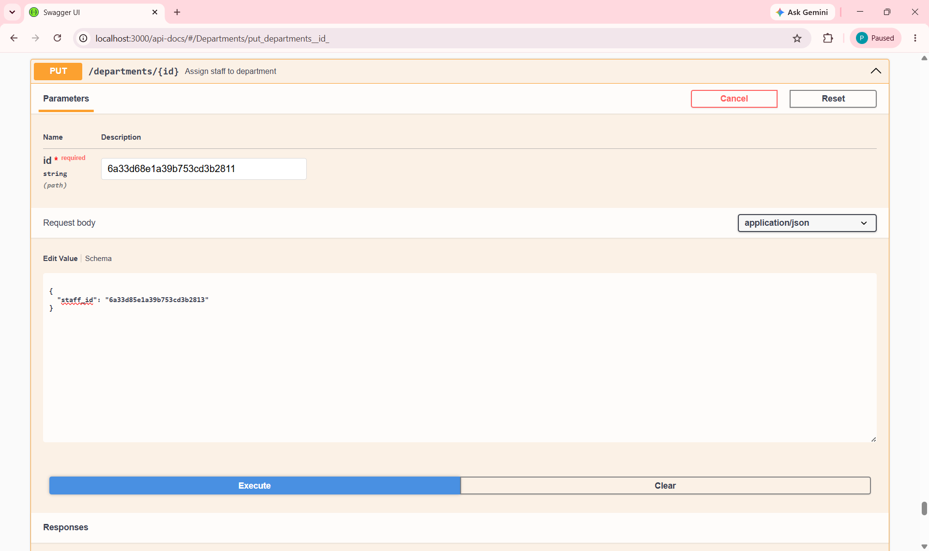
DELETE :
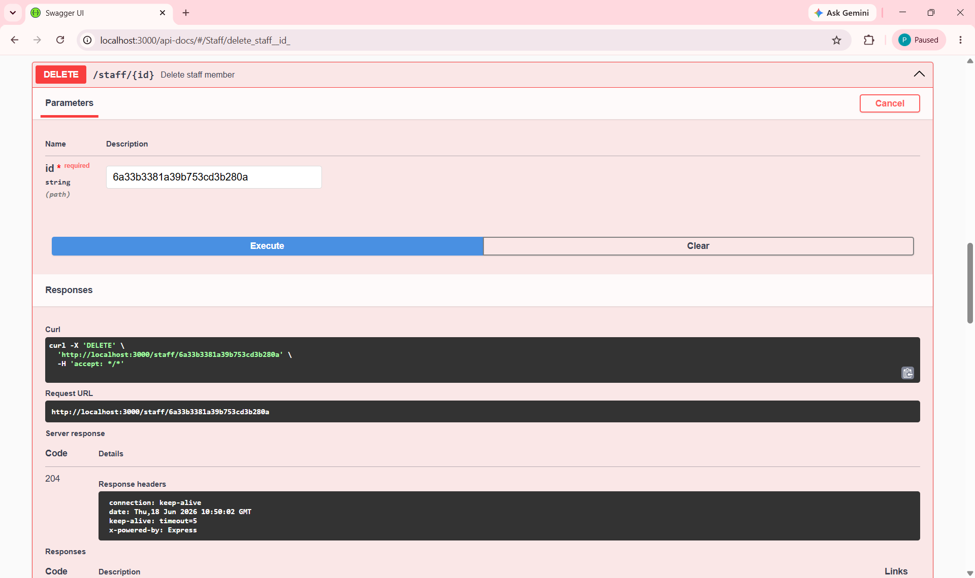
Delete is used to delete the entity via a primary key which is the id here

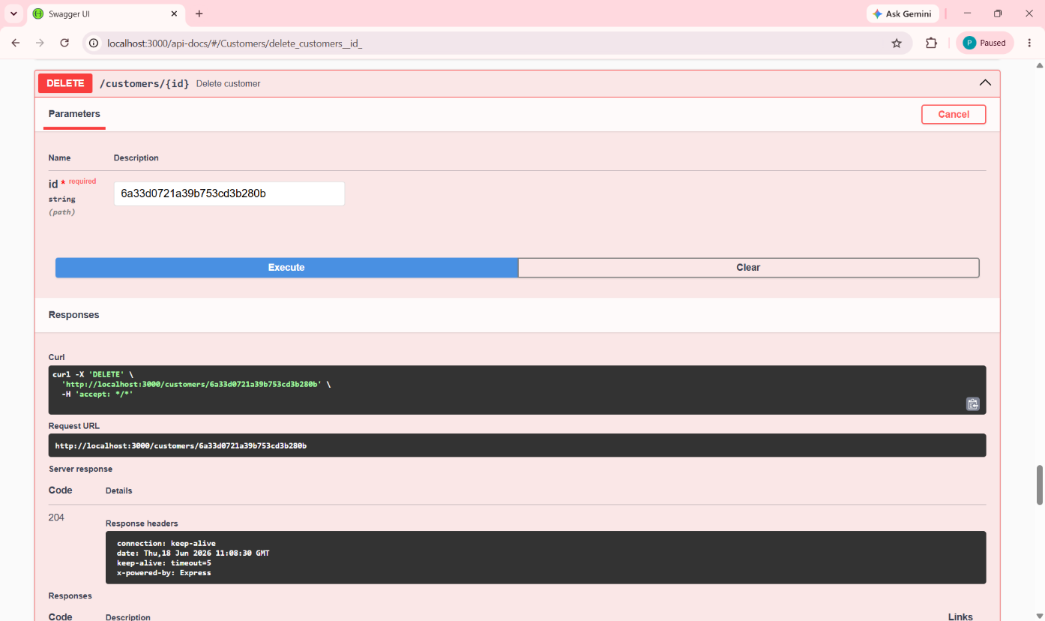

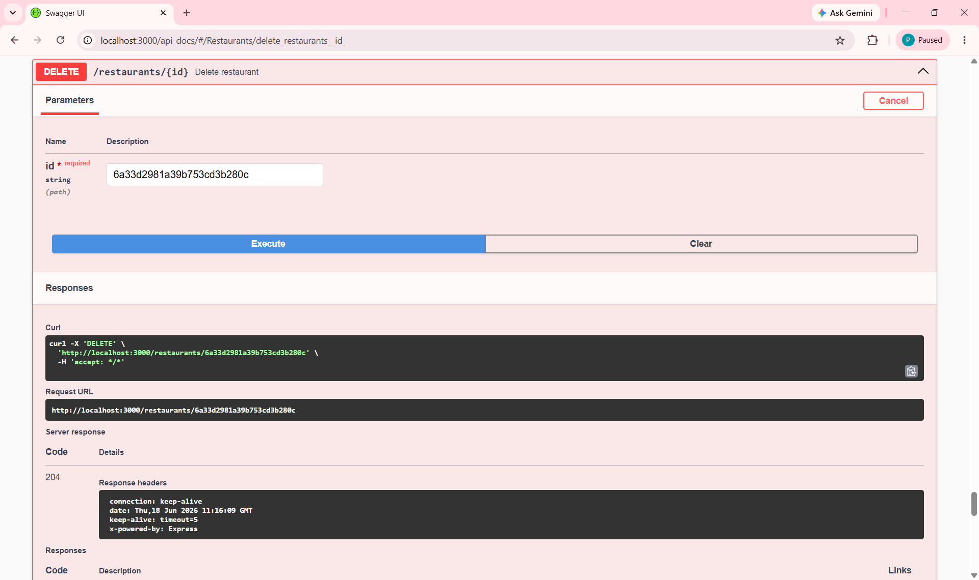

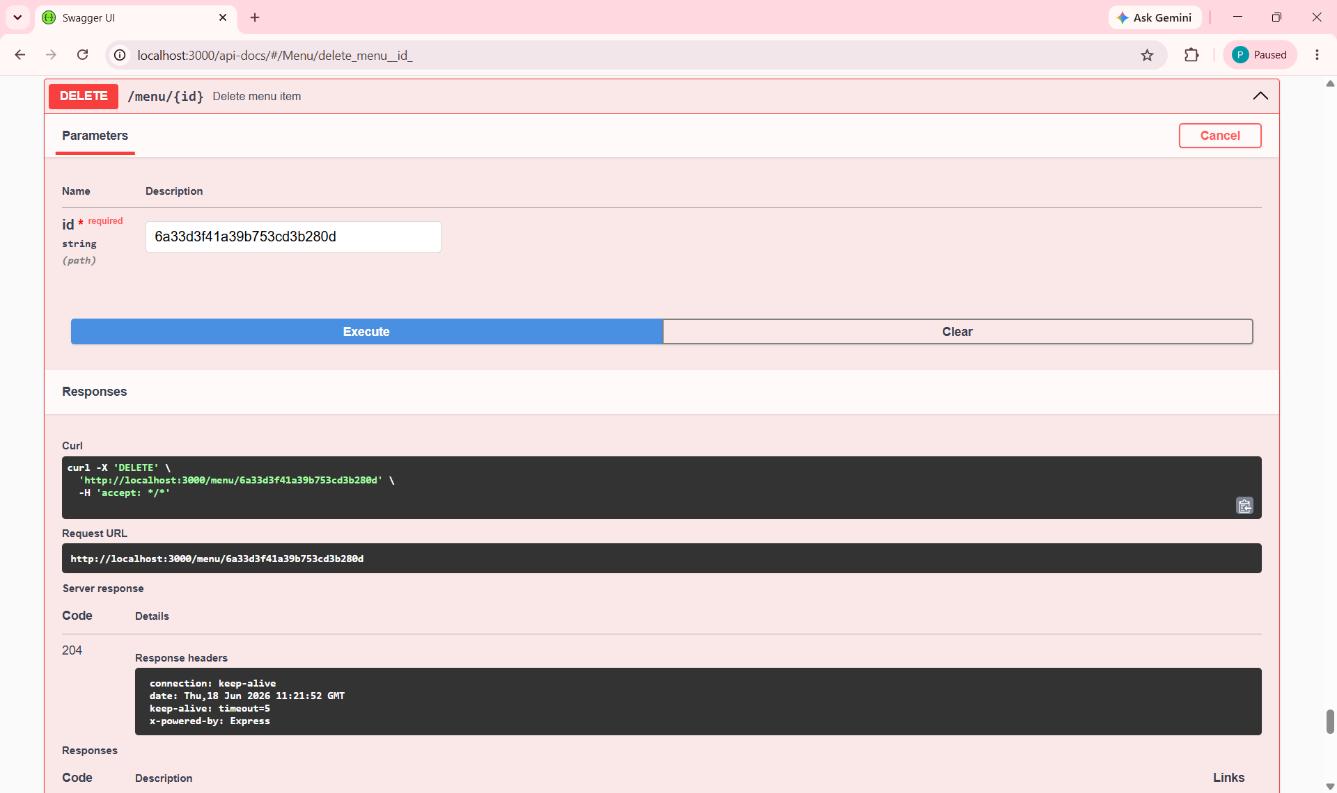

Final Remarks:
This project demonstrates proficiency in:
- Backend Development – Node.js, Express.js
- Database Management – MongoDB, Native Driver
- API Design – RESTful principles, HTTP methods, status codes
- Documentation – Swagger UI
- Testing – API testing with Swagger UI and Postman
- Project Management – Version control, modular coding, environment configuration

Testing & Screenshots
The API was thoroughly tested using Swagger UI. All endpoints were validated for:
- ✅ Successful responses (200, 201, 204)
- ✅ Error handling (400, 404, 500)
- ✅ Data validation
- ✅ CRUD operations
Screenshots of all test cases are provided in the ScreenShots folder.

